Lab – Week 06 – Blog

This week’s lab focussed on the use of gdb to locate errors and understanding its use in debugging programs. In doing so, I was given two bugged programs and asked to find their errors using gdb with the aim of learning gdb’s functionality and consolidate my debugging skills!

The first program was a simple bubble-sort program that appeared to never sort the array given to it. To solve the issue, I had to insert a breakpoint at line 38 in order to print and read the values being inserted to the loop. I was of the opinion that the sorting program was correct in its sorting logic, but was not undergoing any swaps during runtime. This thought was confirmed when I ran the program in gdb and discovered that the program in fact only ran once before exiting to an error. Moreover, I noticed that its exit condition, the value of j, was incrementing after the first iteration of the loop when it should have been decrementing as the program was clearly sorting from its rear to its front!

The second program to be debugged was a doubly-linked queue of items which appeared to be sorted using an algorithm in Queue.c. To begin, I ran the program normally using dcc, yet the program abruptly stopped due to an error which appeared to be located in the declaration of the queueLength. I observed that it appeared as though there was an error when entering the queue, as that was the called function just before queueLength was checked with an assert. Hence, I added a breakpoint when enterQueue was called. I then proceeded through enterQueue which appeared to have no issues with adding items. However, at the end of that function, I noticed (through printing the value of queueLength) that it was not incrementing queueLength when an item was inserted. Hence, I added this line to the given program which fixed the issue. This program allowed me to observe the important use of printing values and using breakpoints to confirm the location of errors at certain points in the program’s runtime.

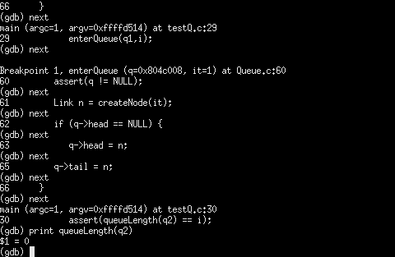

I then proceeded by running the program again, yet another error appeared, this time in Test 2, where there was a ‘Segmentation Fault’. Because of my knowledge from the course so far, I understood there was an error occurring in the linkage between nodes, and hence, I inserted a breakpoint in the enterQueue function to check certain values. My assumption was correct as I noticed during the program’s runtime the value of q→tail did not have link to the node previous to it. Therefore, I read through the enterQueue function to try and fix any issues I could see. I noticed that there were clear issues in the edge case which was supposedly treated in an if-statement. Firstly, if the list was indeed empty, it should set both head and tail to the newly-inserted node, then increment q→size and finally return from the function as that is all that would need to be done. Moreover, to fix the missing link between nodes in a list of ‘more than one element’, I added a line q→tail→next = n which ensured that n was correctly linked to the previous tail (the node before it in the queue list).
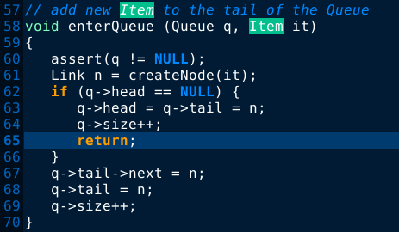

The final error which presented itself was a segmentation fault in leaveQueue, in which the program attempted to remove a node from an already empty list.

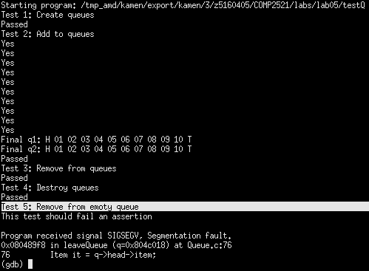

To fix this, I used gdb again by ‘nexting’ through breakpoints to find that the error was indeed in leaveQueue and I knew from the printed statement “This tail should fail an assertion” that the error was simply fixed by inserting an insertion at the start of the call for leaveQueue, which asserted that ‘q’ was not empty before attempting to remove a node.

Hence, this week’s lab exercise was of great use in learning how to find the location of errors through creating breakpoints and printing values which I am certain I will use in future larger programs I create which will be much more difficult to debug without the use of such a program to ‘next’ through lines. (Quick note: it actually acts very similarly to qtspim which I am using to debug Assembly Language programs in COMP1521!)

